Software Design Document
Process Mining of LMS Logs for Understanding Learning Behavior Patterns


Submitted by
Name: M Shahid
Roll No: F22BINFT1M01230

Submitted to
Dr. Mustafa Hameed

Department of Information Technology
Faculty of Computing
The Islamia University of Bahawalpur

Summary
The Process Mining of LMS Logs system is designed to analyze student interaction data generated by Learning Management Systems (LMS) in order to understand learning behavior patterns. The system applies process mining techniques to discover real learning workflows, identify engagement trends, and highlight deviations from expected learning paths.
Key Capabilities:
■ Log-Based Process Discovery: Extracts learning sequences from LMS activity logs.
■ Behavioral Insights: Identifies frequent learning paths, bottlenecks, and inactive patterns.
■ Visual Analytics: Provides dashboards, process models, and charts for instructors.
■ Data-Driven Support: Helps instructors improve course design and student engagement.
Expected Impact:
By using process mining insights, instructors can better understand student behavior, identify learning difficulties early, and make informed decisions to enhance teaching strategies and learning outcomes

Table of Contents
Summary 2
1. System Architecture 4
1.1 System Context 4
1.2 Component Architecture 5
1.3 Component Responsibility Table 6
1.4 Deployment Architecture 6
1.5 Technology Stack 7
2. Detailed Design 9
2.1 Class Diagram 9
2.2 Sequence Diagram 11
2.3 Data Flow Description 11
3. Database Design 14
3.1 Database Schema 14
3.2 Entity Relationship Description 17
3.3 Data Integrity and Security 17
4. User Interface Design 17
4.1 Design Principles 17
4.2 Screen Layouts 17
4.3 Navigation Flow 19
5. Security and Access Control 20
5.1 Authentication Mechanism 20
5.2 Authorization and Role Management 20
5.3 Data Security 20
5.4 Error Handling and Logging 21
6. Performance and Scalability Considerations 22
6.1 Performance Optimization 22
6.2 Scalability 22
6.3 System Reliability 22
7. Limitations and Future Enhancements 23
7.1 System Limitations 23
7.2 Future Enhancements 25
8. Conclusion 25

1. System Architecture
The system follows a modular, data-driven architecture designed to process LMS log data efficiently and generate meaningful learning behavior insights. The architecture separates data ingestion, preprocessing, process mining, and visualization components to ensure scalability, maintainability, and ease of extension. This design allows independent development and testing of each module while supporting smooth data flow across the system.

1.1 System Context
The system operates as an external analytical module that integrates with existing Learning Management Systems. LMS platforms provide log data as input, while instructors and administrators interact with the system to view analysis results and visual dashboards.

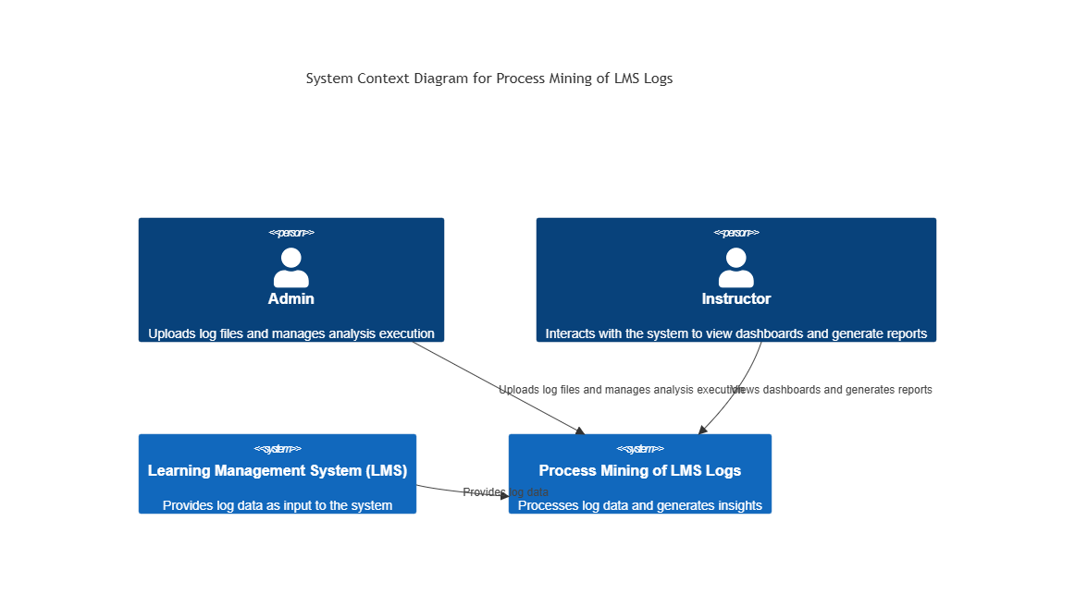
Figure 1.1: System Context Diagram

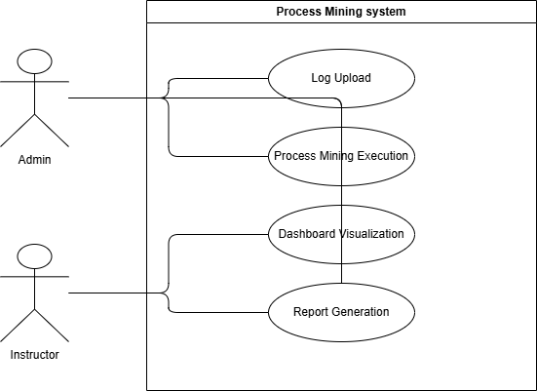
Use Case Diagram

1.2 Component Architecture
The application consists of five loosely coupled components arranged in a processing pipeline. Each component is responsible for a specific stage of data transformation, starting from log ingestion and ending with visualization and reporting.
Core Components:
• Data Ingestion
• Log Preprocessing
• Process Mining Engine
• Analytics & Visualization
• Reporting Module
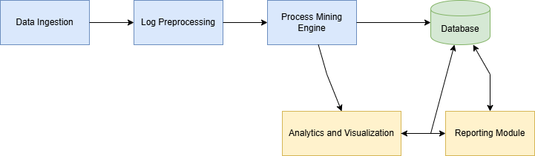
Figure1.2: Component Architecture Diagram

1.3 Component Responsibility Table
Table 1.1: Component Responsibility Matrix
Component Name | Responsibilities
Data Ingestion Module | Collects LMS log files uploaded by the admin. Validates file formats (CSV/XLSX) and ensures data completeness before processing.
Log Preprocessing Module | Cleans raw log data, removes inconsistencies, handles missing timestamps, and transforms logs into structured event formats suitable for process mining.
Process Mining Engine | Applies process discovery algorithms to extract learning workflows, activity sequences, and performance metrics from processed logs.
Analytics & Visualization Module | Generates process models, charts, and dashboards to visually represent learning behavior patterns and engagement trends.
Reporting Module | Compiles analysis results into structured summary reports and allows users to export findings in PDF or HTML format.

1.4 Deployment Architecture
The system is deployed as a web-based application using a client–server architecture. The frontend runs on a web browser and communicates with the backend server through secure HTTP requests. The backend processes LMS logs, executes process mining algorithms, and stores results in a centralized database.
The deployment architecture supports scalability and can be extended to cloud-based environments if required. All sensitive data is protected through role-based access control and secure authentication mechanisms.

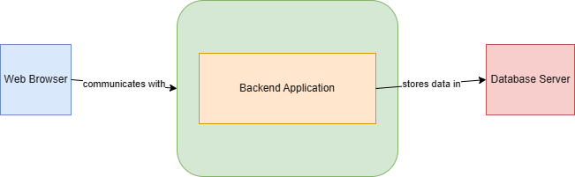
Figure 1.3: Deployment Architecture Diagram

1.5 Technology Stack
Table 1.2: Technology Stack Overview
Layer | Technology / Tool | Purpose
Frontend | HTML, CSS, JavaScript | User interface and dashboard interaction
Backend | Python (Flask/Django) | Business logic and API handling
Process Mining | PM4Py | Process discovery and analysis
Data Processing | Pandas, NumPy | Log preprocessing and transformation
Database | MySQL / PostgreSQL | Data storage
Visualization | Plotly / Matplotlib | Charts and process models
Deployment | Local Server / Cloud | Application hosting

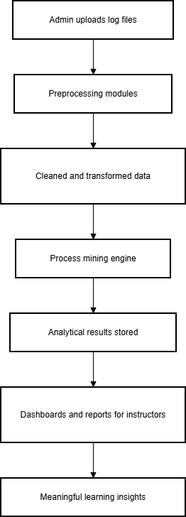

System Architecture Diagram

2. Detailed Design
This section provides a detailed description of the internal design of the system components. It explains how different modules interact with each other, how data flows across the system, and how core functionalities are implemented. The purpose of this section is to give a clear technical understanding of the system’s structure and behavior.

2.1 Class Diagram
The class diagram represents the static structure of the system by showing the main classes, their attributes, and the relationships between them. It helps in understanding how data is organized and how different entities interact within the system.
Main Classes Description:
- User: Represents system users such as Admin and Instructor. It stores authentication and role-related information.
- LMS_Log: Stores raw activity data generated by students within the LMS, including timestamps and activity types.
- Process_Model: Represents the discovered process models generated through process mining techniques.
- Analysis_Result: Stores insights, performance metrics, and identified bottlenecks extracted from process models.

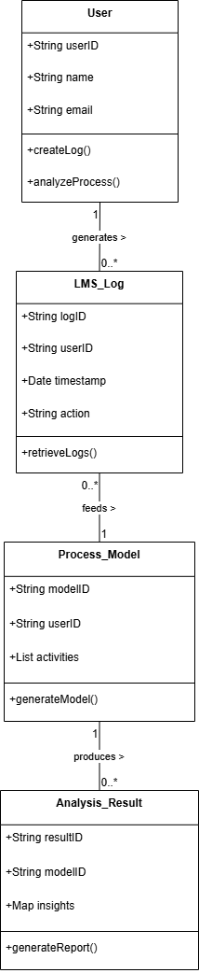
Figure 2.1: Class Diagram of the System

2.2 Sequence Diagram
The sequence diagram illustrates the interaction between system actors and components over time. It shows how requests are initiated, processed, and responded to in a sequential order during LMS log analysis.
Scenario: LMS Log Processing and Analysis
- Admin uploads the LMS log file.
- The system validates and preprocesses the uploaded data.
- The Process Mining Engine analyzes the logs.
- A process model is generated and stored.
- The dashboard displays the analysis results to the user.

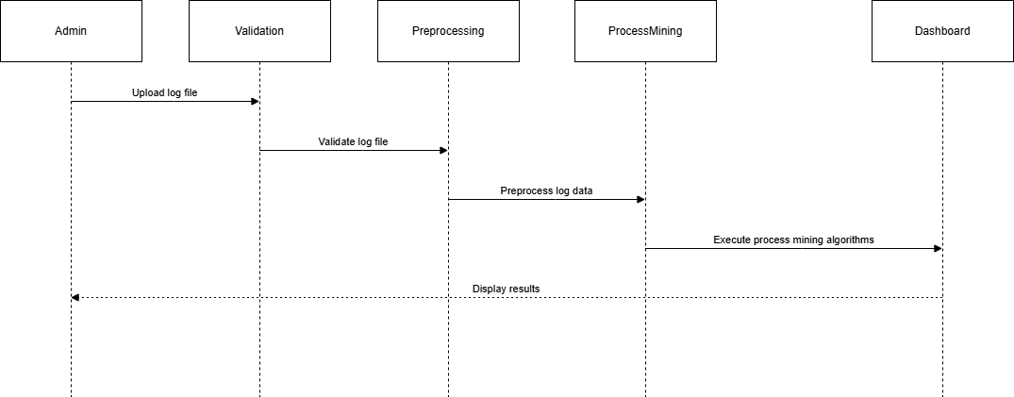
Figure 2.2: Sequence Diagram for LMS Log Processing

2.3 Data Flow Description
The data flow in the system begins with LMS log file submission and ends with visualization and report generation. Initially, raw log data is uploaded and passed to the preprocessing module, where it is cleaned and transformed. The processed data is then forwarded to the process mining engine, which extracts workflows and learning patterns. Finally, the analytics module presents the results through dashboards and reports.
This structured data flow ensures consistency, traceability, and efficient analysis of learning behavior.
External Entities
- Admin
- Instructor
Processes
- Upload LMS Logs
- Preprocess Logs
- Perform Process Mining
- Generate Dashboard & Report
Data Stores
- LMS Log Database
- Analysis Results Database
Data Flows
- Log File
- Cleaned Logs
- Process Model
- Insights / Reports

Figure 2.3: Data Flow Diagram of LMS Log Analysis System

3. Database Design
This section describes the database structure used to store LMS logs, user information, process models, and analysis results. The database is designed to support efficient data retrieval, maintain data integrity, and ensure scalability for large volumes of log data.

3.1 Database Schema
The database schema defines the structure of tables, their attributes, and relationships. The schema follows normalization principles to minimize redundancy and ensure consistency across stored data.

Main Tables:

Table 3.1.1: User Table
Field Name | Description
user_id (PK) | Unique identifier for each user
name | Full name of the user
email | Email address used for login
role | Defines user role (Admin or Instructor)
password | Encrypted password for authentication

Table 3.1.2: LMS_Log Table
Field Name | Description
log_id (PK) | Unique identifier for each log entry
user_id (FK) | References the User table
activity_type | Type of LMS activity performed
timestamp | Date and time of the activity
course_id | Identifier of the related course

Table 3.1.3: Process_Model Table
Field Name | Description
model_id (PK) | Unique identifier for the process model
discovery_type | Type of process mining technique used
generated_date | Date when the model was generated
performance_metrics | Calculated performance indicators

Table 3.1.4: Analysis_Result Table
Field Name | Description
result_id (PK) | Unique identifier for analysis result
model_id (FK) | References the Process_Model table
insights_summary | Summary of extracted insights
bottlenecks | Identified process bottlenecks

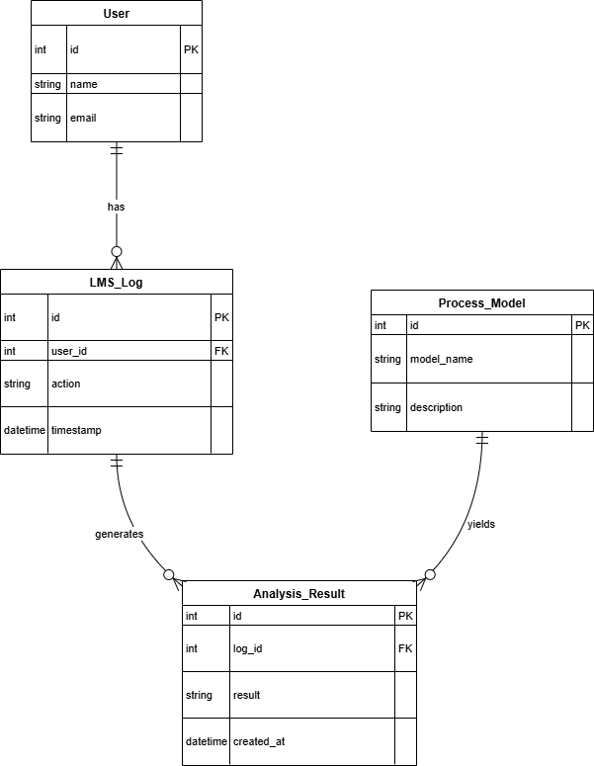
Figure 3.1: Database Schema Diagram

3.2 Entity Relationship Description
The User entity has a one-to-many relationship with the LMS_Log entity, as one user can generate multiple log entries. The LMS_Log data serves as the primary input for the process mining engine.
Each Process_Model is generated from a collection of LMS logs and can produce multiple Analysis_Result records. These relationships ensure traceability from raw data to analytical insights and support effective reporting.

3.3 Data Integrity and Security
To ensure data accuracy and security, the system applies primary and foreign key constraints. Role-based access control restricts sensitive operations such as log uploads and analysis execution to authorized users only. Passwords are stored in encrypted form, and database access is secured through controlled authentication mechanisms.

4. User Interface Design
This section describes the design of the user interface, including screen layouts, navigation flow, and interaction elements. The interface is designed to be user-friendly, intuitive, and visually clear, allowing users to easily perform system tasks and understand analytical results.

4.1 Design Principles
The user interface follows the following design principles:
- Simplicity: Clean layouts with minimal clutter to improve usability.
- Consistency: Uniform color schemes, fonts, and controls across all screens.
- Usability: Easy navigation with clear labels and actions.
- Responsiveness: Optimized for desktop and laptop screen resolutions.

4.2 Screen Layouts
4.2.1 Login Screen
The login screen allows users to authenticate themselves before accessing the system.
Components:
- Email input field
- Password input field
- Login button
Functionality:
- Validates user credentials
- Displays error messages for incorrect login attempts

4.2.2 Log Upload Screen
This screen enables the admin to upload LMS log files for analysis.
Components:
- File upload control (CSV/XLSX)
- Upload button
- Status message area
Functionality:
- Validates file format
- Confirms successful upload

4.2.3 Dashboard Screen
The dashboard presents analytical results in a visual form.
Components:
- Process flow diagrams
- Charts and graphs
- Filters for data exploration
Functionality:
- Displays learning behavior insights
- Allows users to navigate between visualizations

4.2.4 Report Generation Screen
This screen allows instructors to generate and download summary reports.
Components:
- Generate report button
- Report preview area
- Download options (PDF/HTML)
Functionality:
- Compiles analysis results
- Provides downloadable reports

4.3 Navigation Flow
The navigation flow ensures smooth movement between system screens. After login, users are directed to the dashboard, from where they can access log upload, analysis, and report generation features based on their role.

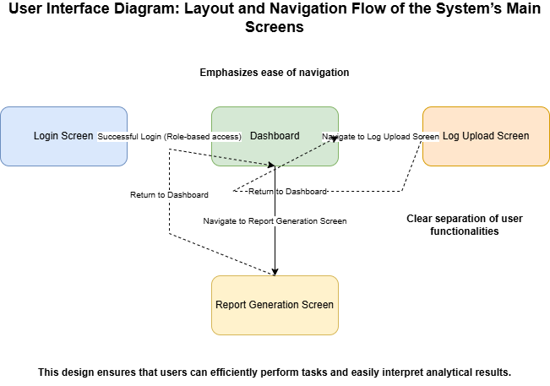

5. Security and Access Control
This section explains the security mechanisms implemented in the system to protect user data, ensure authorized access, and maintain system integrity. The design focuses on authentication, authorization, and data protection.

5.1 Authentication Mechanism
The system uses a secure authentication mechanism to verify user identity before granting access. Users must provide valid login credentials to enter the system. Authentication is handled on the server side to prevent unauthorized access.
Security Features:
- Email and password-based login
- Password encryption before storage
- Server-side credential validation

5.2 Authorization and Role Management
The system implements role-based access control (RBAC) to manage user permissions.
User Roles:
- Admin: Allowed to upload LMS logs and run process mining analysis
- Instructor: Allowed to view dashboards and generate reports
Each role has restricted access to specific system features, ensuring proper separation of responsibilities.

5.3 Data Security
To protect sensitive information, the system applies security measures at both application and database levels. Data transmission between frontend and backend is secured using standard communication protocols.
Security Measures:
- Encrypted password storage
- Restricted database access
- Input validation to prevent malicious data submission

5.4 Error Handling and Logging
The system logs authentication failures, file upload errors, and system exceptions. Error messages are designed to be informative without revealing sensitive system details.

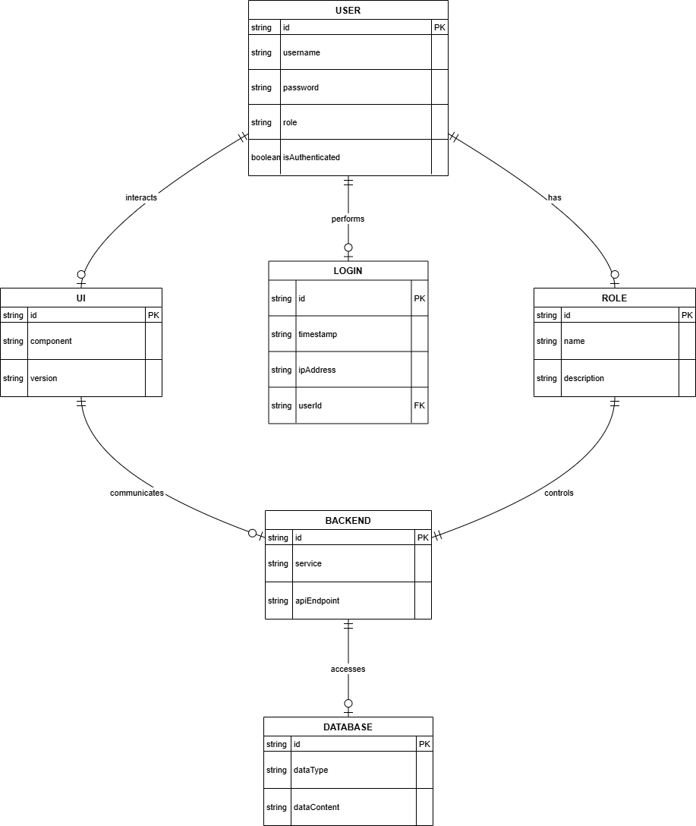
Security and Access Control Diagram

6. Performance and Scalability Considerations
This section discusses the design considerations related to system performance, efficiency, and scalability. The system is designed to handle large volumes of LMS log data while maintaining acceptable response times and reliable operation.

6.1 Performance Optimization
The system optimizes performance through efficient data preprocessing and modular processing. Log files are validated and cleaned before analysis to reduce unnecessary computation. Process mining algorithms are executed only after successful data validation to ensure optimal use of system resources.
Caching mechanisms are used to store processed results, allowing dashboards to load quickly without repeated computations.

6.2 Scalability
The modular architecture allows the system to scale as data volume increases. Additional processing resources can be allocated to the process mining engine when handling large datasets. The database design supports scalability by organizing log data efficiently and enabling indexing on frequently accessed fields.

6.3 System Reliability
The system ensures reliability through error handling and data validation at each processing stage. In case of system failures, error logs are maintained to assist in troubleshooting and recovery.

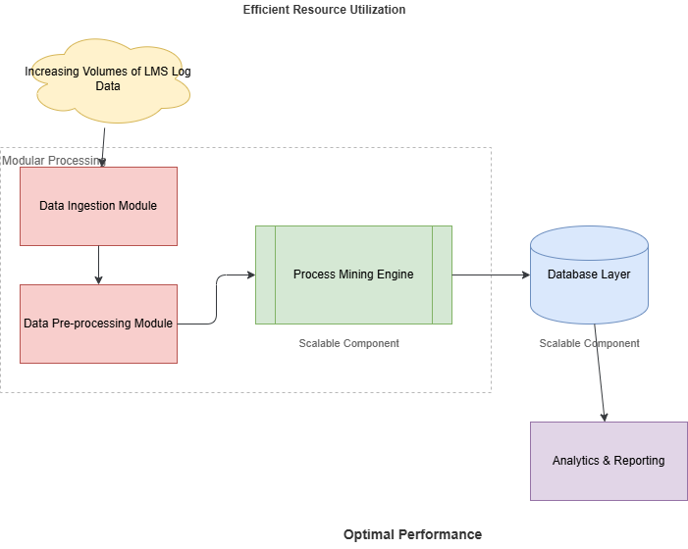

7. Limitations and Future Enhancements
This section highlights the current limitations of the system and suggests possible improvements that can be implemented in future versions to enhance functionality and performance.

7.1 System Limitations
- The system relies on the availability and quality of LMS log data; incomplete or inconsistent logs may affect analysis accuracy.
- Real-time process mining is not supported in the current version, as analysis is performed on uploaded log files.
- The system currently supports a limited set of process mining algorithms.

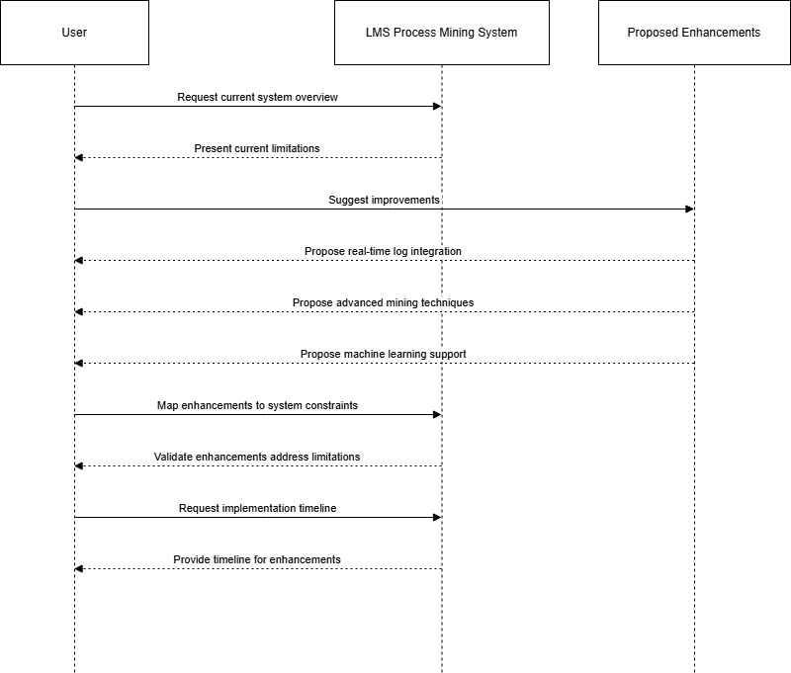

Figure 7.1: Limitations and Future Enhancements

7.2 Future Enhancements
Future versions of the system may include the following enhancements:
- Integration with LMS platforms for real-time log collection.
- Support for additional process mining techniques such as conformance checking and predictive analysis.
- Advanced visualization features, including interactive process maps and personalized dashboards.
- Machine learning-based recommendations to predict student performance and engagement risks.

8. Conclusion
The Software Design Document presents a detailed design of the Process Mining of LMS Logs system. It explains the system architecture, component responsibilities, database design, user interface, and security mechanisms. The design supports scalability, maintainability, and effective analysis of learning behavior patterns. This document serves as a technical reference for system development and future enhancements.

